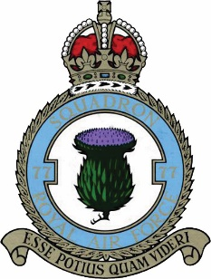

You are warmly invited to mark the

80th Anniversary of 77 arriving at RAF Elvington

Saturday 8th October 2022
Yorkshire Air Museum & Allied Air Force Memorial, Elvington, York, YO41 4AU
Programme:
10.00: Museum open with free admission for Registrants (normally £12 pp)
11.00: Chapel Service conducted by the Revd Taff Morgan and Wreath Laying at the Memorial
12.30 pm: Hot and Cold Buffet Lunch in the Halifax Suite
Afternoon: Pre-booked Halifax tours* and entertainment on site
Register £15.00 per person to include lunch.
Name (s) ----------------------------------------------------------------------------------------------------
- Reserve .............. places for the tour of Handley Page Halifax, Friday the Thirteenth, at £25pp, veterans free (normal price for descendants £60). Tours are limited to two parties of four with priority given to Association members. Over 12’s only and you must be able to negotiate the cramped quarters inside.
I wish to book places for the 77 Squadron Reunion:
Name: ................................................................................................................................................................
Address: .............................................................................................................................................................. ...................................................................................................................................................................................................Telephone.....................................Email.........................................................................................
Total Payment: £............... .... Cheques to be made out to 77 Squadron Association or by PayPal using the email: info@77squadron.org.uk or using the Donate button on the website: 77squadron.org.uk or return this booking form to: Hon Treasurer & Membership Secretary : Van Wilson, 20 Grange Garth, York, YO10 4BS before 30th September. You can contact Rachel Semlyen for further information. rachel@yorkshireairmuseum.org

We look forward to welcoming you back or meeting you for the first time!

